SQL Assignment 4

1. Create a stored procedure in the Northwind database that will calculate the average
value of Freight for a specified customer.Then, a business rule will be added that will
be triggered before every Update and Insert command in the Orders controller,and
will use the stored procedure to verify that the Freight does not exceed the average
freight. If it does, a message will be displayed and the command will be cancelled.

Before Insert Trigger :

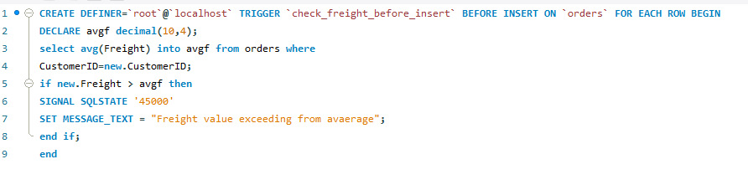
Before Update Trigger :

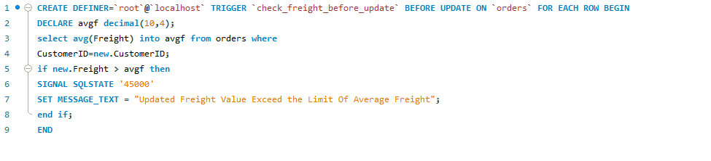

2. write a SQL query to Create Stored procedure in the Northwind database to retrieve
Employee Sales by Country

call procedure :

call employeeSalesByCountry();/* Q-2 */

store procedure :

CREATE DEFINER=`root`@`localhost` PROCEDURE `employeeSalesByCountry`()
BEGIN
select e.EmployeeID,e.FirstName,o.ShipCountry,sum(od.Quantity*od.UnitPrice) as 'Amount Of Sale' from employees as e left join orders as o on o.EmployeeID=e.EmployeeID join `order details` as od on od.OrderID=o.OrderID group by e.EmployeeID,o.ShipCountry;
END

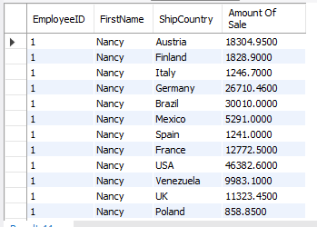

3. write a SQL query to Create Stored procedure in the Northwind database to retrieve
Sales by Year

call procedure :

call SalesbyYear();/* Q -3 */

stored procedure :

CREATE DEFINER=`root`@`localhost` PROCEDURE `SalesbyYear`()
BEGIN
select year(orders.OrderDate) 'Selling Year', sum(`order details`.UnitPrice * `order details`.Quantity) Sales from `order details` inner join orders on `order details`.OrderID=orders.OrderID group by year(orders.OrderDate);
END

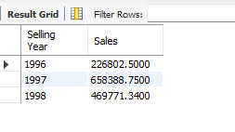

4. write a SQL query to Create Stored procedure in the Northwind database to retrieve
Sales By Category

call procedure :

call salesByCategories();

Stored Procedure :

CREATE DEFINER=`root`@`localhost` PROCEDURE `salesByCategories`()
BEGIN
select categories.CategoryID,sum(`order details`.Quantity* `order details`.UnitPrice) as 'Sales' from categories left join products on products.CategoryID=categories.CategoryID join `order details` on `order details`.ProductID=products.ProductID group by categories.CategoryID;
END

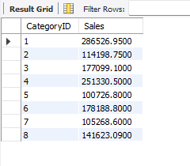

5. write a SQL query to Create Stored procedure in the Northwind database to retrieve
Ten Most Expensive Products

Call Procedure :

call topTen();

Stored Procedure:

CREATE DEFINER=`root`@`localhost` PROCEDURE `topTen`()
BEGIN
select * from products order by UnitPrice desc limit 10;
END

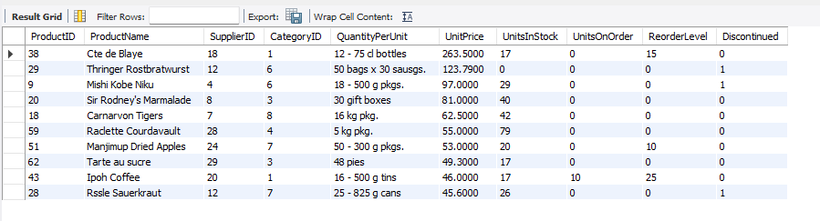

6. write a SQL query to Create Stored procedure in the Northwind database to insert
Customer Order Details

Call Procedure :

call insertOrderDetails(10250,8,42,12,2.2);

Stored Procedure :

CREATE DEFINER=`root`@`localhost` PROCEDURE `insertOrderDetails`(
in oid int,
in pd int,
in up decimal(10,4),
in qty smallint ,
in dsc double(8,0))
BEGIN
INSERT INTO `northwind`.`order details`
(`OrderID`,
`ProductID`,
`UnitPrice`,
`Quantity`,
`Discount`)
VALUES
(oid,
pd,
up,
qty,
dsc);
END

7. write a SQL query to Create Stored procedure in the Northwind database to update
Customer Order Details

Call Procedure:

call updateOrderDetails(10248,11,14,12,1);

Stored Procedure :

CREATE DEFINER=`root`@`localhost` PROCEDURE `updateOrderDetails`(
in oid int,
in pd int,
in up decimal(10,4),
in qty smallint ,
in dsc double(8,0))
BEGIN
update northwind.`order details` set
UnitPrice=up,
Quantity=qty,
Discount=dsc where OrderID=oid and productID=pd;
END

